Advocacy support  If you need help making your complaint the Health Complaints Advocacy Service (HCAS) for Beds and Herts is:  POhWER  Hertlands House, Primett Road  STEVENAGE  Herts SG1 3EE  Telephone: 0300 456 2370 (local rate)  Email: pohwer@pohwer.net  Website: www.pohwer.net  Further action  If you are dissatisfied with the outcome of your complaint from either Central East ICB or The Garden City Practice, then you can escalate your complaint to Parliamentary Health Service Ombudsman (PHSO). Please check their website for up-to-date information.  Tel: 0345 015 4033  www.ombudsman.org.uk | The Garden City Practice  Birdcroft Road  Welwyn Garden City, Herts AL8 6EH  01707 321500 gcp.practicemanager@nhs.net |  | The Complaints Process  - The Garden City Practice  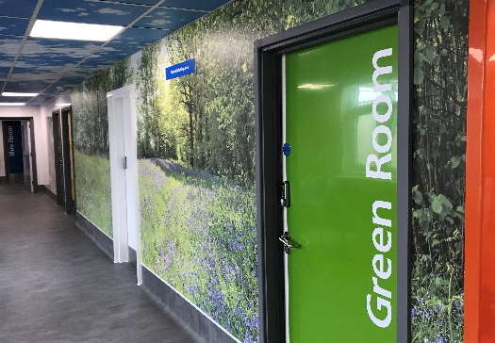
  Talk to us  Every patient has the right to make a complaint about the treatment or care they have received at The Garden City Practice.  We understand that we may not always get everything right and, by telling us about the problem you have encountered, we will be able to improve our services and patient experience.  Who to Contact  Most complaints can be resolved at a local level. Please speak to a member of staff if you have a concern and they will assist you where possible. Alternatively, ask to speak to the Complaints Manager, Karen Ratcliff but note this may need to be a booked appointment. Our preference is for your complaint to be in writing to ensure we have all the correct details to investigate.  If for any reason you do not want to speak to a member of our staff, then you can request that the Integrated Care Board (ICB) investigates your complaint. | They will contact us on your behalf:  Central East Integrated Care Board  Telephone:01992 566122  Email: blmkicb.contactus@nhs.net  Write: Central East ICB Patient Experience Team  First Floor Kao Park2  London Road, Harlow, CM17 9NA  A complaint can be made verbally or in writing. A complaints form is available via our website. Additionally, you can complain via email to gcp.practicemanager@nhs.net . All complaints are responded to in writing by post to maintain confidentiality within the practice.  Time frames for complaints  The time constraint on bringing a complaint is 12 months from the occurrence giving rise to the complaint, or 12 months from the time you become aware of the matter about which you wish to complain.  The complaints manager will respond to within three business days to acknowledge your complaint.  We will aim to investigate and provide you with the findings as soon as we can and will provide regular updates regarding the investigation of your complaint. For minor concerns we aim to respond within 10 working days; for more complex complaints there is no timescale, but we will endeavour to as soon as possible and within 6 months. |  | Investigating complaints  We will investigate all complaints effectively and in conjunction with current legislation and guidance.  Confidentiality  We will ensure that all complaints are investigated with the utmost confidentiality and that any documents are held separately from the patient’s healthcare record.  Third party complaints  We allow third parties to make a complaint on behalf of a patient. The patient must provide consent for them to do so. A third-party patient complaint form is available from reception.  Final response  We will issue a final formal response to all complainants which will provide full details and the outcome of the complaint. We will liaise with you about the progress of any complaint if there are any significant delays. We If we cannot provide a final response within 6 months you can progress to the PHSO details overleaf.

